# **Lab #5**

**Objective: To learn conceptual and logical DW Design**

1. **Draw M/ERDs for the following scenarios represented by ERDs and business rules to ease your task.**
2. **Scenario 1: Clown registry**

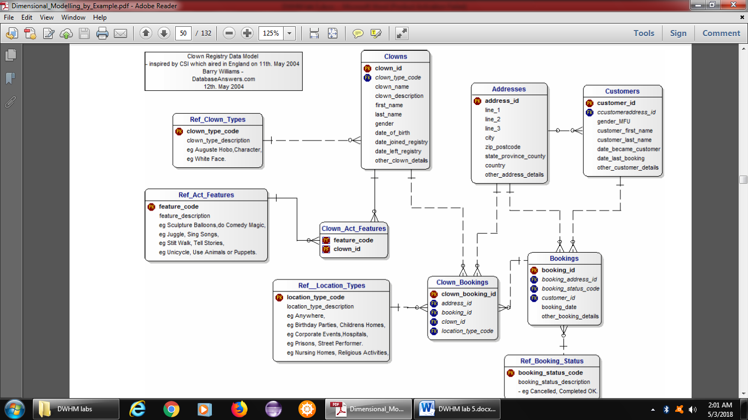

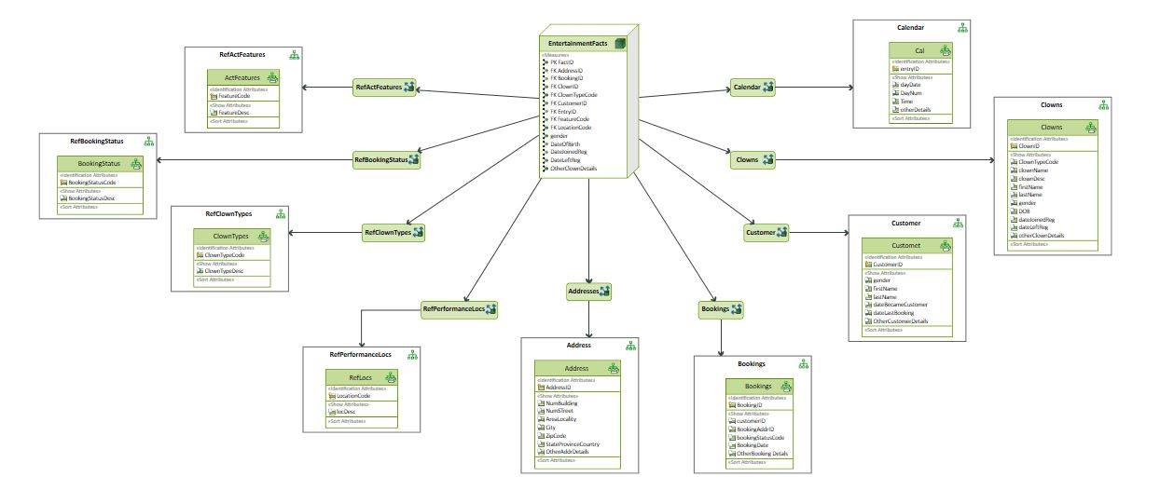

1. **Scenario 2: Amusement Parks**



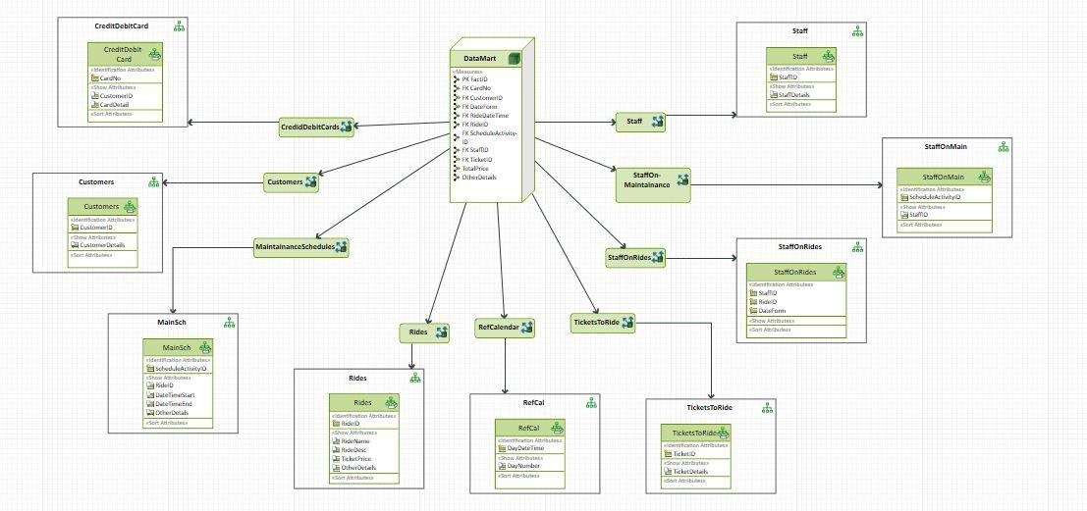

1. **Scenario 3: Advertising**



